


SAVEETHA INSTITUTE OF MEDICAL AND TECHNICAL SCIENCES (SIMATS)
Saveetha School of Engineering
Department of Computer Science and Engineering

SOFTWARE ENGINEERING
Test Case Design Assignment
TITLE : Design and Development of an Online Auction System with Real-Time Bidding

Submitted By
Name : Akileshwaran A
Register Number : 192511354
GUIDED BY

Course Faculty : Dr. K. ANITADAVAMANI

SIMATS ENGINEERING
Saveetha Institute of Medical and Technical Sciences Chennai - 602105
August- 2026

TABLE OF CONTENTS

S NO | CONTENT | PAGE NO
1 | Functional and Non-Functional Requirements | 3
2 | Test Scenarios | 4
3 | Test Design Techniques Applied | 5
4 | Detailed Test Cases | 6
5 | Requirement Traceability Matrix | 11
6 | Test Coverage Summary | 11
7 | Test Execution Evidence – LiveBid Prototype Screenshots | 12

1. Functional and Non-Functional Requirements

1.1 Functional Requirements
ID | Requirement
FR1 | The system shall allow buyers and sellers to register and log in securely.
FR2 | The system shall allow a seller to create an auction listing with item details, starting price, minimum bid increment, reserve price, and start/end time.
FR3 | The system shall allow authenticated buyers to view live auctions and place bids in real time.
FR4 | The system shall validate that every new bid exceeds the current highest bid by at least the minimum increment.
FR5 | The system shall broadcast the updated highest bid to all connected users in real time (within acceptable latency).
FR6 | The system shall run a countdown timer for each auction and automatically close bidding when it reaches zero.
FR7 | The system shall automatically declare the highest valid bidder as the winner when the auction closes, subject to the reserve price.
FR8 | The system shall route the winning bidder to a payment gateway to complete the transaction.
FR9 | The system shall send real-time notifications (in-app/email) to outbid users and to the auction winner.
FR10 | The system shall allow an administrator to monitor, edit, or remove auction listings.

1.2 Non-Functional Requirements
ID | Requirement
NFR1 | Performance: Bid updates must be reflected to all connected clients within 2 seconds.
NFR2 | Reliability/Concurrency: The system must correctly resolve simultaneous bids without double-accepting or losing a bid (no race conditions).
NFR3 | Security: The system must authenticate all bidding actions and prevent bid tampering, replay, and injection attacks.
NFR4 | Usability: The bidding interface must clearly display current highest bid, time remaining, and bid status.
NFR5 | Scalability: The system must support a high volume of concurrent users during peak bidding without degradation.
NFR6 | Availability: The system must maintain at least 99.9% uptime during scheduled live auctions.

2. Test Scenarios
The following scenarios were identified to provide requirement and functional coverage across normal, boundary, invalid, and exceptional conditions.
ID | Requirement
TS01 | Verify user registration and login (valid and invalid credentials).
TS02 | Verify seller can create a valid auction listing.
TS03 | Verify seller cannot create a listing with invalid schedule (end time before start time).
TS04 | Verify a buyer can place a valid bid above the current highest bid plus increment.
TS05 | Verify boundary behaviour of bid amount around the minimum increment.
TS06 | Verify the system rejects invalid bids (below increment, negative, non-numeric, equal to current bid).
TS07 | Verify real-time broadcast of the updated highest bid to all connected clients.
TS08 | Verify correct resolution when two users submit competing bids simultaneously (concurrency).
TS09 | Verify bids are rejected once the auction countdown reaches zero / auction is closed.
TS10 | Verify automatic winner declaration when the auction closes with the reserve price met.
TS11 | Verify auction outcome when the reserve price is not met.
TS12 | Verify auction outcome when zero bids are placed.
TS13 | Verify outbid notifications are sent to the previous highest bidder.
TS14 | Verify payment flow for the winning bidder, including payment failure handling.
TS15 | Verify unauthenticated users cannot place bids.
TS16 | Verify the system resists SQL injection / malicious input in the bid field.
TS17 | Verify auction state transitions (Scheduled → Live → Closed → Sold/Unsold).
TS18 | Verify administrator can remove a fraudulent or invalid listing.

3. Test Design Techniques Applied
- Equivalence Partitioning (EP): Used to classify bid amounts and user inputs into valid classes (e.g., bid ≥ current highest + increment) and invalid classes (e.g., negative, non-numeric, below increment).
- Boundary Value Analysis (BVA): Used around the minimum bid increment boundary — testing bids equal to the current highest bid, exactly at the increment, and one unit below the increment (TC07–TC09).
- Decision Table Testing: Used to determine expected system behaviour based on combinations of conditions — user authenticated (Y/N), auction status (Scheduled/Live/Closed), and bid validity (Valid/Invalid) — see table below.
- State Transition Testing: Used to verify the auction lifecycle — Scheduled → Live → Closing → Closed → Sold/Unsold — and to confirm bids are only accepted in the Live state (TC12, TC14, TC23).

3.1 Decision Table – Bid Acceptance Logic
User Authenticated | Auction Status | Bid Amount Valid | System Outcome
No | Live | – | Reject – redirect to login
Yes | Scheduled | – | Reject – auction not started
Yes | Closed | – | Reject – auction has ended
Yes | Live | No (< increment/negative/non-numeric) | Reject – validation error shown
Yes | Live | Yes (≥ current highest + increment) | Accept – bid recorded and broadcast

3.2 State Transition – Auction Lifecycle
Scheduled → Live → Closing (countdown) → Closed → Sold (reserve met) / Unsold (reserve not met or no bids). Bids are permitted only in the Live state; any attempt outside this state is rejected (see TC14, TC23).

4. Detailed Test Cases
Actual Result and Pass/Fail Status are filled in for the test cases already executed against the LiveBid prototype (evidence in Section 7); the remaining rows are left blank for completion during further test execution.
TC ID | Test Scenario | Test Steps | Test Data | Expected Result | Actual Result | Technique | Pass/Fail
TC01 | Valid user registration | 1. Open the registration page.  2. Enter valid name, email, password, and role (Buyer/Seller).  3. Submit the form. | Name: Arun Kumar; Email: arun@mail.com; Password: Auction@123 | Account is created successfully and a confirmation message/email is shown. |  | EP
TC02 | Login with valid credentials | 1. Open the login page.  2. Enter registered email and correct password.  3. Click Login. | Email: arun@mail.com; Password: Auction@123 | User is authenticated and redirected to the auction dashboard. | Logged in with demo account; dashboard greeted user as “Hi, demo” confirming an authenticated session (see Fig. 2). | EP | Pass
TC03 | Login with invalid password | 1. Open the login page.  2. Enter registered email with a wrong password.  3. Click Login. | Email: arun@mail.com; Password: wrongPass1 | Login is rejected; error message “Invalid credentials” is displayed. |  | EP (Invalid class)
TC04 | Create a valid auction listing | 1. Log in as Seller.  2. Enter item title, description, starting price, increment, reserve price, start time, end time.  3. Publish listing. | Item: Vintage Watch; Start Price: ₹5000; Increment: ₹100; Start: Today 10:00; End: Today 18:00 | Listing is created and appears in the live/upcoming auction list. | Listing “MacBook Pro 14” (₹80,000 starting price) was created and appeared on the Live Auctions dashboard with an ACTIVE badge (see Fig. 1, Fig. 3). | EP | Pass
TC05 | Create listing with end time before start time | 1. Log in as Seller.  2. Enter a start time later than the end time.  3. Attempt to publish. | Start: Today 18:00; End: Today 10:00 | System rejects the listing with a validation error on the date/time fields. |  | BVA / Exceptional
TC06 | Place a valid bid above current highest + increment | 1. Log in as Buyer.  2. Open a live auction with current highest bid ₹5000, increment ₹100.  3. Enter a bid of ₹5200 and submit. | Current highest: ₹5000; Increment: ₹100; New bid: ₹5200 | Bid is accepted; new highest bid ₹5200 is recorded and displayed. | Bid of ₹4,00,000 on “Apple Mac pro 14” was accepted; system displayed “Bid accepted.” and updated current highest bid and bid history to “demo – ₹4,00,000” (see Fig. 5). | EP (Valid class) | Pass
TC07 | Place bid exactly equal to current highest bid | 1. Open a live auction with current highest bid ₹5000.  2. Enter a bid of exactly ₹5000.  3. Submit. | Bid amount: ₹5000 (= current highest) | Bid is rejected; message “Bid must be higher than current highest bid” is shown. |  | BVA (lower boundary, invalid)
TC08 | Place bid exactly at minimum increment above current bid | 1. Open a live auction, current highest ₹5000, increment ₹100.  2. Enter a bid of exactly ₹5100.  3. Submit. | Bid amount: ₹5100 (current + increment) | Bid is accepted as the new highest bid. |  | BVA (valid boundary)
TC09 | Place bid one unit below minimum increment | 1. Open a live auction, current highest ₹5000, increment ₹100.  2. Enter a bid of ₹5099.  3. Submit. | Bid amount: ₹5099 | Bid is rejected as it does not meet the minimum increment requirement. |  | BVA (invalid boundary)
TC10 | Place a negative bid amount | 1. Open a live auction.  2. Enter a negative bid value.  3. Submit. | Bid amount: -500 | System rejects the input with a validation error; no bid is recorded. |  | EP (Invalid class)
TC11 | Place a non-numeric bid value | 1. Open a live auction.  2. Enter alphabetic text in the bid field.  3. Submit. | Bid amount: “abc” | System rejects the input; field-level validation error is displayed. |  | EP (Invalid class)
TC12 | Two users bid the same amount simultaneously | 1. Two buyers open the same live auction.  2. Both submit a bid of ₹5200 at the same instant.  3. Observe system behaviour. | Concurrent bid amount: ₹5200 from User A and User B | Only one bid is accepted (first valid request per server timestamp); the second user receives an “outbid/try again” message. No duplicate or lost bid occurs. |  | State Transition / Concurrency
TC13 | Real-time bid broadcast to all connected users | 1. Open the same auction on two different devices/browsers.  2. Place a valid bid from Device A.  3. Observe Device B. | New bid: ₹5300 | Device B's displayed highest bid updates to ₹5300 within 2 seconds without a manual refresh. |  | Normal flow
TC14 | Attempt to bid after auction end time | 1. Wait for/simulate an auction whose countdown has reached zero.  2. Attempt to submit a new bid. | Bid amount: ₹5500 on a closed auction | Bid is rejected; message “Auction has closed” is displayed; bid is not recorded. |  | State Transition (invalid)
TC15 | Auction closes and highest bidder is declared winner | 1. Allow a live auction's countdown to reach zero with reserve price met.  2. Observe auction status and winner declaration. | Final highest bid: ₹6200; Reserve price: ₹5000 | Auction status changes to “Closed – Sold” and the highest bidder is declared the winner. |  | Normal flow / State Transition
TC16 | Auction closes without meeting reserve price | 1. Allow an auction to close where the final highest bid is below the reserve price.  2. Observe auction outcome. | Final highest bid: ₹4500; Reserve price: ₹5000 | Auction status changes to “Closed – Unsold”; no winner is declared; bidder is notified reserve was not met. |  | Exceptional
TC17 | Auction closes with zero bids placed | 1. Allow an auction with no bids to reach its end time.  2. Observe auction outcome. | Number of bids: 0 | Auction status changes to “Closed – No Bids”; seller is given an option to relist. | “MacBook Pro 14” auction ended with no bids placed; card shows Highest bidder: “No bids yet”, Time remaining 00:00, Status: CLOSED (see Fig. 4). | Boundary / Exceptional | Pass
TC18 | Outbid notification sent to previous highest bidder | 1. User A places the highest bid.  2. User B places a higher valid bid.  3. Check User A's notifications. | User A bid: ₹5000; User B bid: ₹5200 | User A receives an outbid notification within a few seconds of User B's bid being accepted. |  | Normal flow
TC19 | Successful payment by winning bidder | 1. Auction closes with User A as winner.  2. User A proceeds to the payment gateway.  3. Complete payment with valid details. | Winning amount: ₹6200; Valid payment card details | Payment is processed successfully; order/transaction is confirmed and receipt is generated. |  | Normal flow
TC20 | Payment failure for winning bidder | 1. Auction closes with User A as winner.  2. User A proceeds to payment with an invalid/declined card.  3. Observe system response. | Winning amount: ₹6200; Invalid card details | Payment fails gracefully; system either allows retry or offers the item to the next-highest bidder as per policy. |  | Exceptional
TC21 | Unauthenticated user attempts to bid | 1. Log out or open the auction page in a guest/incognito session.  2. Attempt to enter and submit a bid. | Bid amount: ₹5200 without login | System blocks the action and redirects the user to the login page; no bid is recorded. |  | Security / Invalid
TC22 | SQL injection attempt in bid field | 1. Open a live auction.  2. Enter a SQL injection payload in the bid amount field.  3. Submit. | Bid amount: 5000; DROP TABLE bids;-- | Input is rejected/sanitised as invalid numeric data; no database operation is executed; error is logged. |  | Security
TC23 | Bid attempt on a Scheduled (not yet live) auction | 1. Open an auction listing whose status is “Scheduled” (start time in the future).  2. Attempt to place a bid. | Auction status: Scheduled | Bidding controls are disabled/hidden; system displays “Auction has not started yet.” |  | State Transition (invalid)
TC24 | Administrator removes a fraudulent listing | 1. Log in as Administrator.  2. Locate the flagged/fraudulent listing.  3. Remove or suspend the listing. | Listing ID: AUC-1042 (flagged) | Listing is removed/suspended and no longer visible or biddable to buyers; action is logged. |  | Normal flow

5. Requirement Traceability Matrix
Maps each requirement to its corresponding test scenario(s) and test case(s), demonstrating full requirement and functional coverage.
Requirement(s) | Test Scenario(s) | Test Case(s)
FR1, NFR3 | TS01, TS15, TS21 | TC01, TC02, TC03, TC21
FR2 | TS02, TS03 | TC04, TC05
FR3, FR4, NFR3 | TS04, TS05, TS06, TS16 | TC06, TC07, TC08, TC09, TC10, TC11, TC22
FR5, NFR1 | TS07 | TC13
FR6, NFR2 | TS08, TS09, TS17 | TC12, TC14, TC23
FR7 | TS10, TS11, TS12 | TC15, TC16, TC17
FR8 | TS14 | TC19, TC20
FR9 | TS13 | TC18
FR10 | TS18 | TC24

6. Test Coverage Summary
- Requirements covered: 10 functional (FR1–FR10) and 6 non-functional (NFR1–NFR6) requirements, all mapped to at least one test scenario.
- Scenarios covered: 18 test scenarios (TS01–TS18) spanning registration/authentication, listing creation, bidding, real-time updates, concurrency, auction closure, notifications, payments, and security.
- Test cases designed: 24 test cases (TC01–TC24) covering normal, boundary, invalid, and exceptional conditions.
- Techniques applied: Equivalence Partitioning, Boundary Value Analysis, Decision Table Testing, and State Transition Testing.
- Condition coverage: Includes functional correctness, boundary limits on bid increments, concurrency/race-condition handling, security (authentication and injection), and full auction lifecycle state coverage.

7. Test Execution Evidence – LiveBid Prototype Screenshots
The following screenshots were captured while executing selected test cases against the working LiveBid prototype (127.0.0.1:5000), and support the Actual Result entries recorded in Section 4.

Fig. 1 – Live Auctions Dashboard (supports TC04)
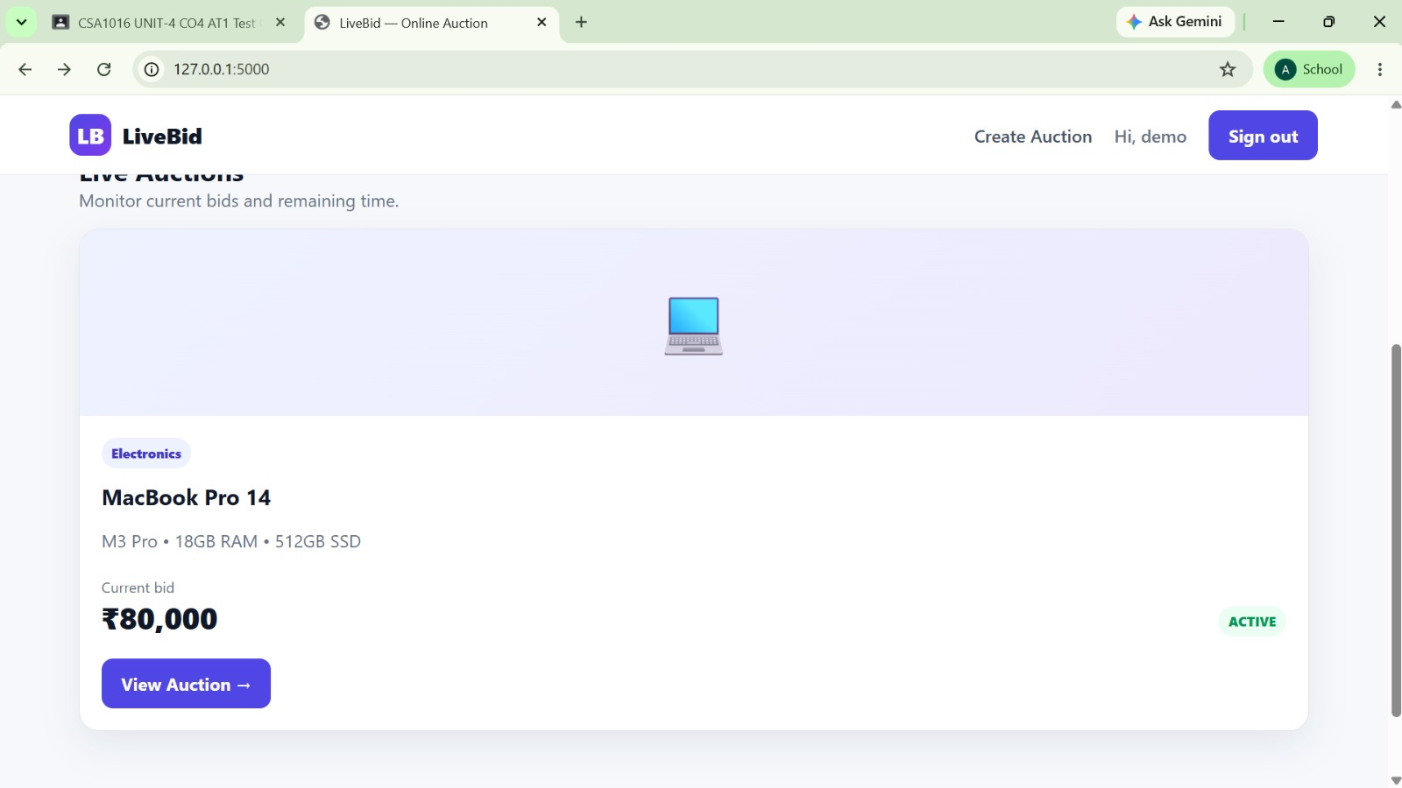
The “MacBook Pro 14” listing created during TC04 is displayed on the dashboard with category, description, current bid ₹80,000, and an ACTIVE status badge, confirming the listing was published successfully.

Fig. 2 – Sign-in Page (supports TC02)
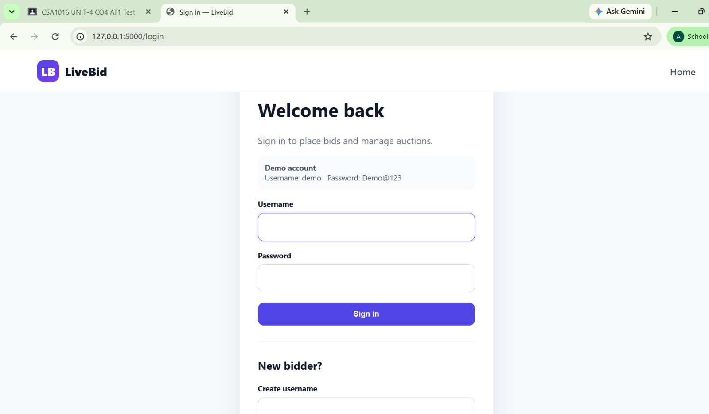
The login screen accepts the demo account credentials (username: demo). A successful sign-in redirects to the dashboard, where the header greets the user as “Hi, demo” (Fig. 1), confirming authentication succeeded.

Fig. 3 – Create Auction Form
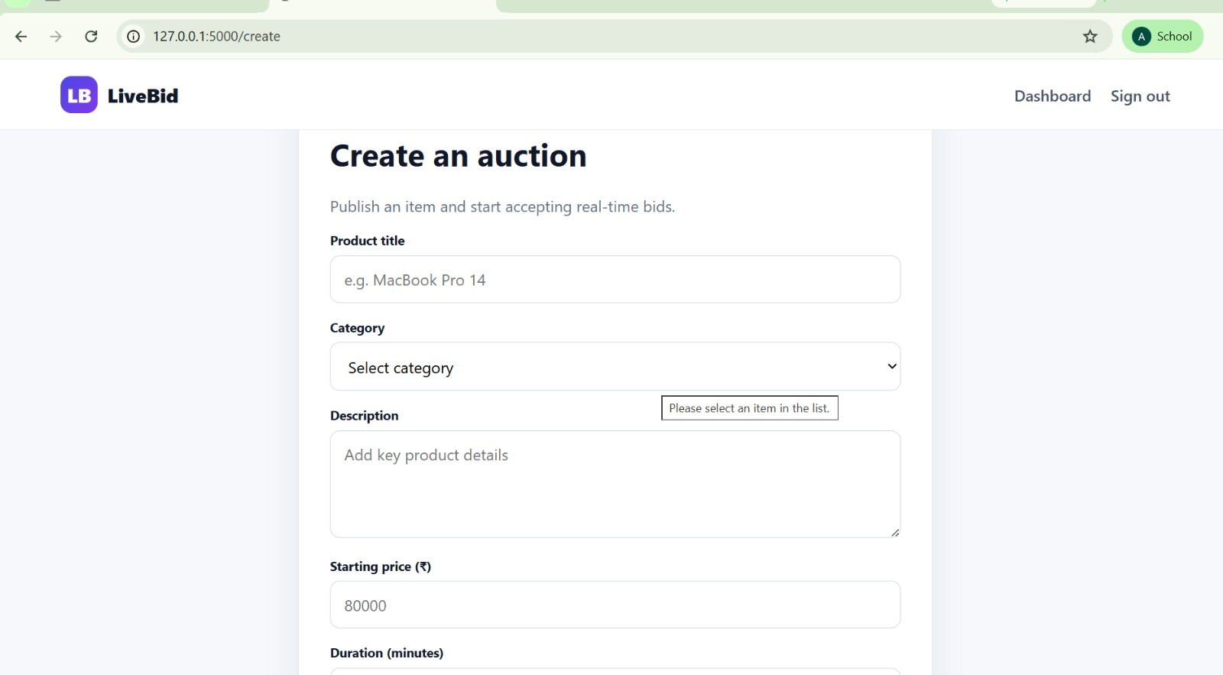
The Create Auction form used for TC04/TC05, showing product title, category, description, starting price, and duration fields. The tooltip “Please select an item in the list” demonstrates the form's built-in field-level validation on the required Category selector.

Fig. 4 – Closed Auction with No Bids (supports TC17)
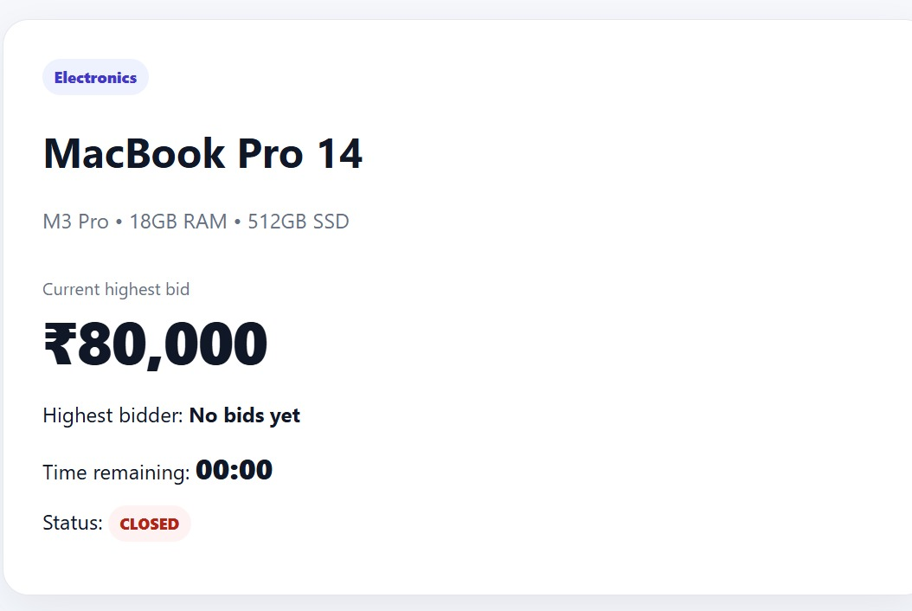
This auction card shows Highest bidder: “No bids yet”, Time remaining 00:00, and Status: CLOSED — the expected outcome when an auction ends without any bids being placed.

Fig. 5 – Valid Bid Accepted (supports TC06)
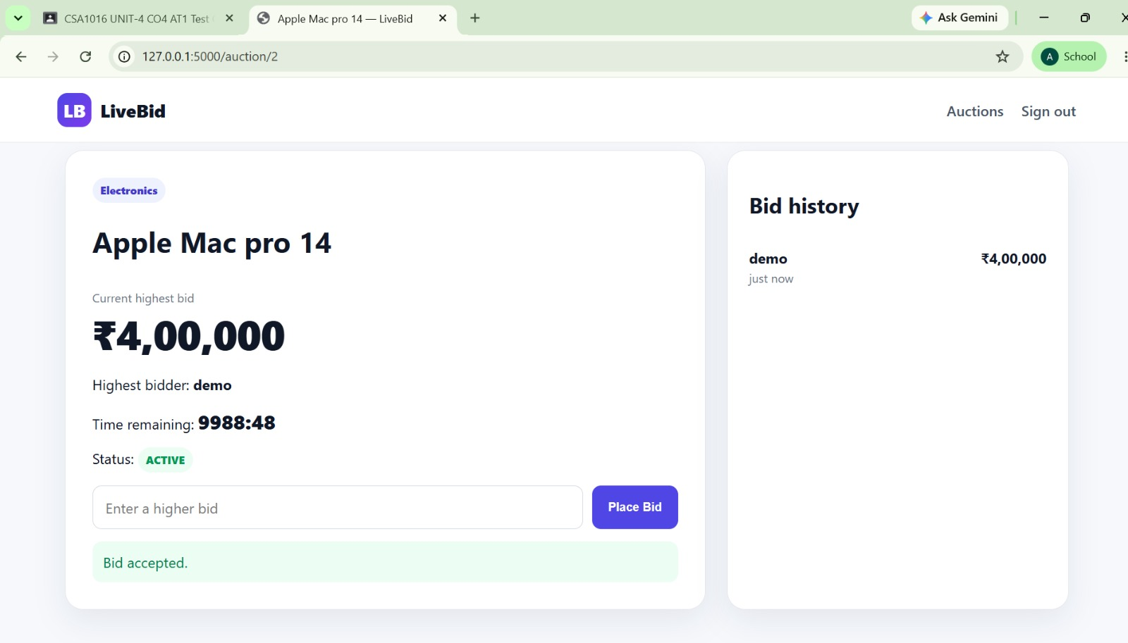

A bid of ₹4,00,000 placed on the “Apple Mac pro 14” auction was accepted; the system displays the confirmation message

